Sennheiser MD 421 Kompakt Awarded 41st Annual NAMM TEC Award for Technical Achievement

Streamlined Evolution of Legendary Microphone Recognized for Innovation in Microphones – Sound Reinforcement

Anaheim, California, Jan 23, 2025 — Audio specialist Sennheiser today announced that the MD 421 Kompakt, a compact version of the legendary MD 421 dynamic microphone, has received the 41st Annual NAMM TEC Award for Outstanding Technical Achievement. Selected by a panel of industry professionals and a broader vote of pro audio peers, the award recognizes the MD 421 Kompakt’s ability to deliver iconic large-diaphragm performance in a modernized, multipurpose form factor.

The MD 421 Kompakt introduces a streamlined approach to miking, retaining the legendary capsule and sonic DNA of the MD 421-II while significantly reducing the physical footprint. By eliminating the traditional bass roll-off switch — a function now standard in modern mixing desks and DAWs — Sennheiser has created a highly versatile tool optimized for high-density stages and tight studio setups, such as toms, guitar cabs, and horns.

The MD 421 Kompakt has received a NAMM TEC Award | 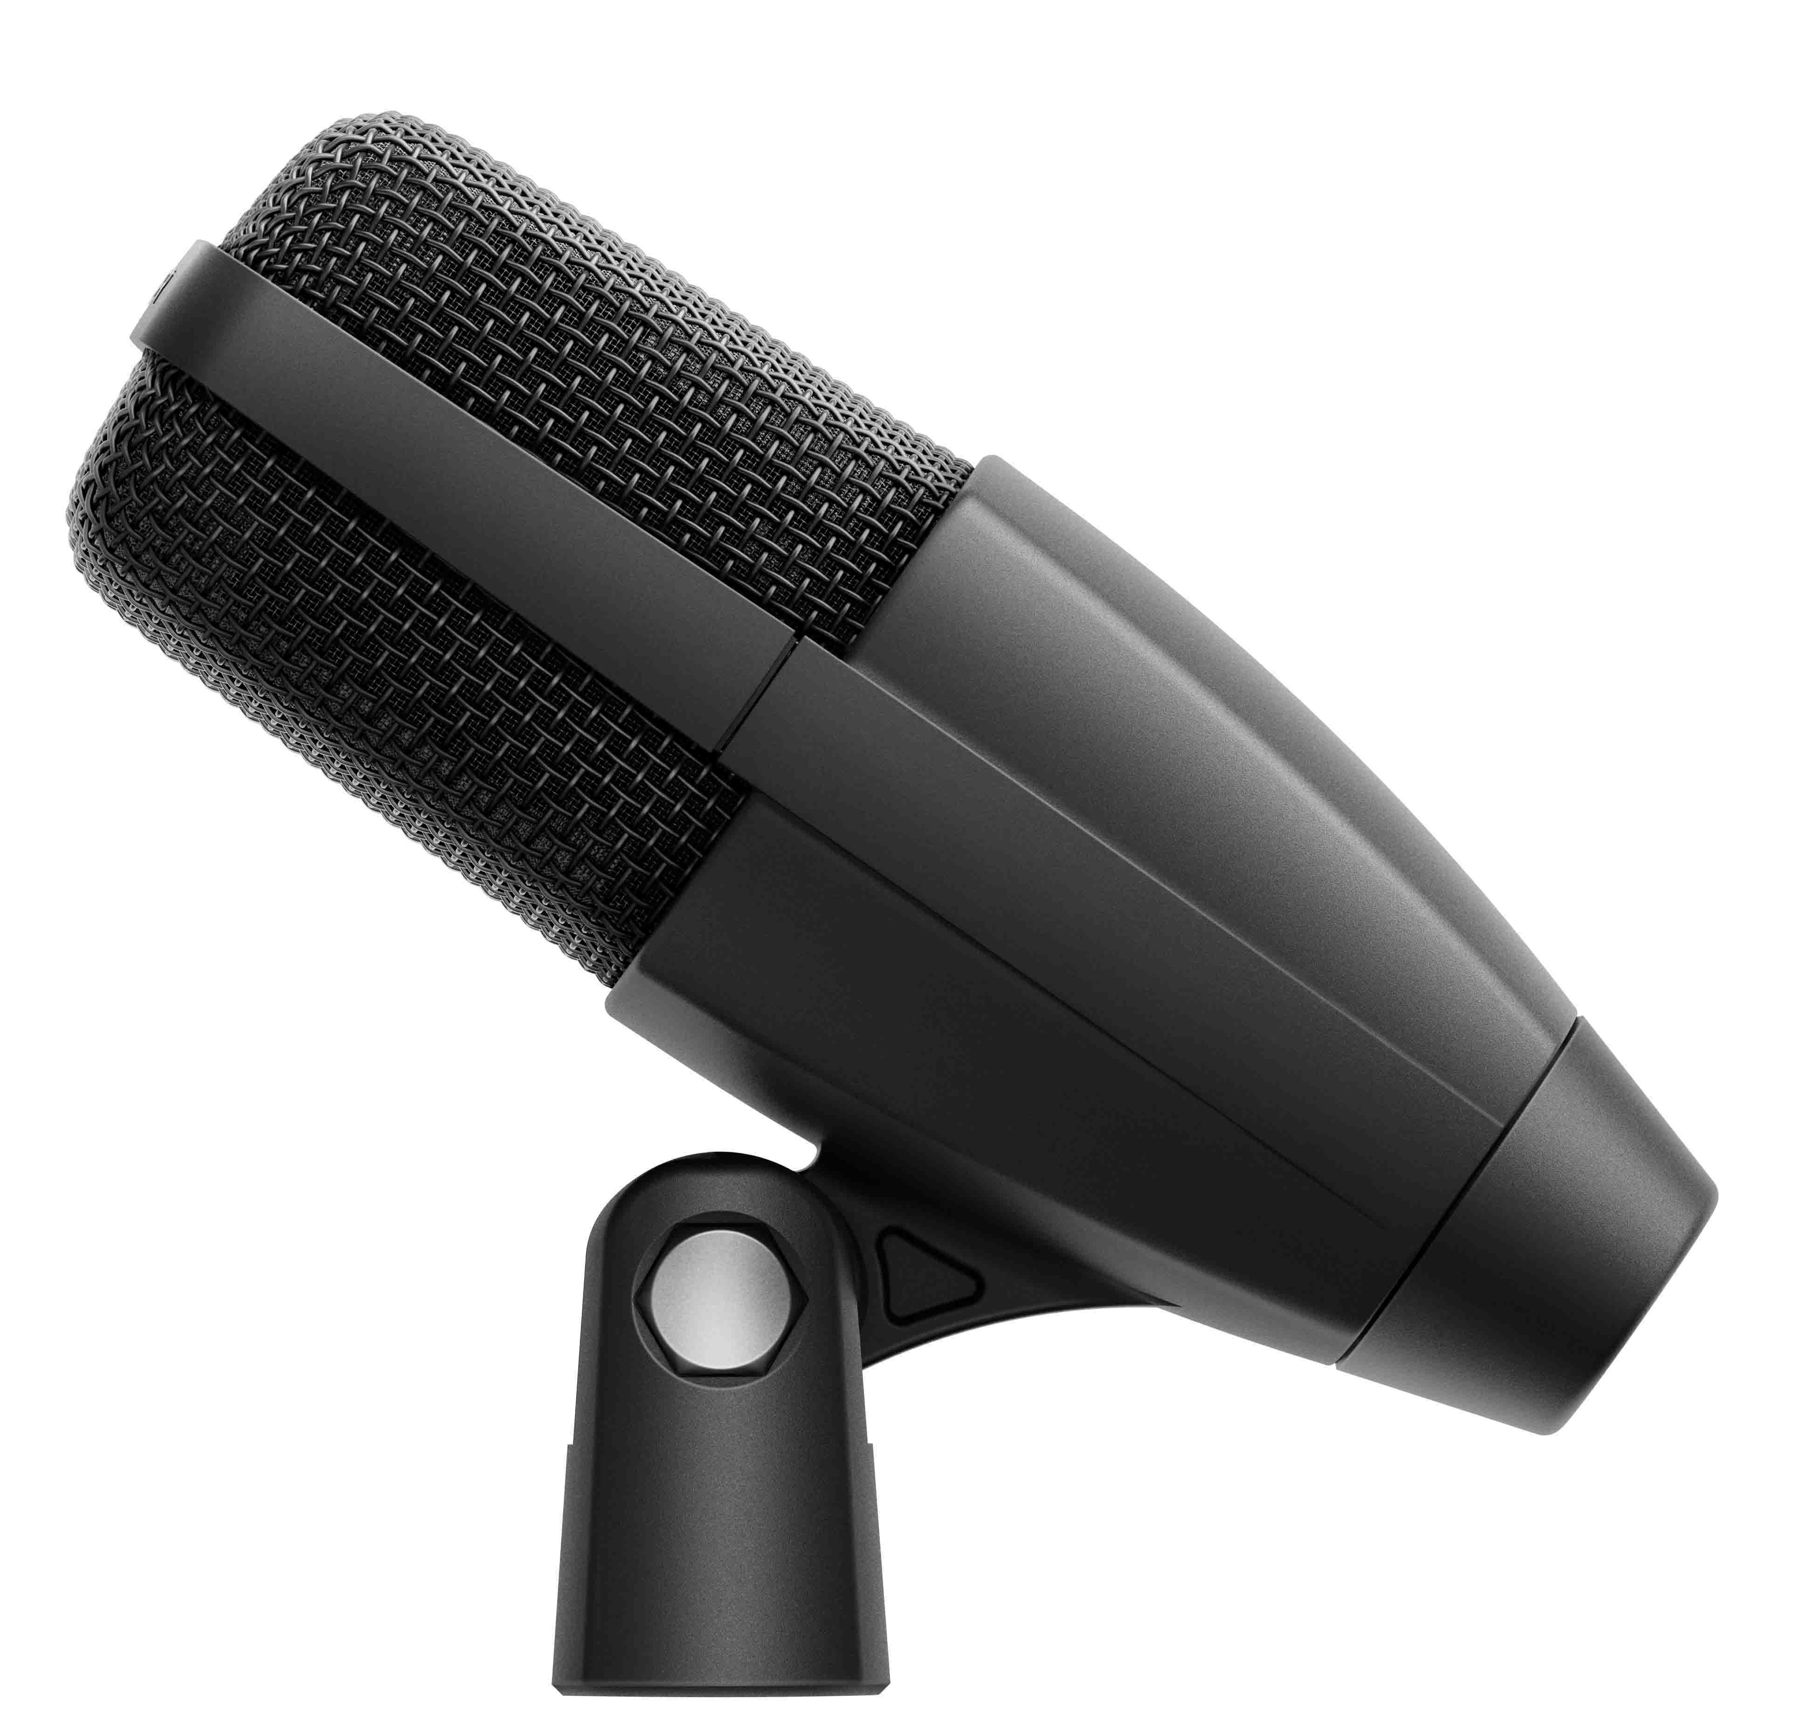

The microphone features a cardioid pick-up pattern and remarkable dynamic range, engineered to handle exceptionally high sound pressure levels in demanding environments. Beyond its sonic performance, the MD 421 Kompakt features an entirely redesigned, integrated mounting clip that addresses long-standing user feedback, providing a fail-safe mounting solution for performers and technicians. This technical recognition at the 41st TEC Awards highlights the microphone’s utility in modern live production and recording applications.

“The MD 421 is a true audio icon, and with the MD 421 Kompakt we continue its legacy while solving real-world challenges for today’s stages and studios,” said Jimmy Landry, Global Category Market Manager, MI at Sennheiser. “Being recognized by the TEC Awards at NAMM celebrates both our heritage and our commitment to exceptional sound.”

 | CEO Dr. Andreas Sennheiser (l.) and Jimmy Landry, Global Category Market Manager, MI

The TEC Awards recognize technical innovations in recordings, live performances, and multimedia. Now in its 41st year, the program honors the products and individuals that contribute to the advancement of audio technology.

(Ends)

About the Sennheiser brand
We live and breathe audio. We are driven by the passion to create audio solutions that make a difference. Building the future of audio and bringing remarkable sound experiences to our customers – this is what the Sennheiser brand has represented for 80 years. While professional audio solutions such as microphones, meeting solutions, streaming technologies and monitoring systems are part of the business of Sennheiser electronic SE & Co. KG, the business with consumer devices such as headphones, soundbars and speech-enhanced hearables is operated by Sonova Holding AG under the license of Sennheiser.

www.sennheiser.com
www.sennheiser-hearing.com

Local Press Contacts
Daniella Kohan Peter Schuyler
daniella.kohan@sennheiser.com peter@ingearpr.com
+1 860 227-2235 +1 917 496-8970

